Intro to SQL Commands - DCL

✅ What is SQL Commands – DCL (Data Control Language)?
# Source: AI Source: Provided by: [Data Path: Persons Table -> ID Column: 1, Name_En Column: Motasem Essam] -> From: [ChatGPT] on [6/11/2026]
DCL stands for Data Control Language, and it's used to control access to data in the database. These commands help manage permissions and user privileges — i.e., who can read, modify, or administer data and objects.

🧩 Core DCL Commands:
# Source: AI Source: Provided by: [Data Path: Persons Table -> ID Column: 1, Name_En Column: Motasem Essam] -> From: [ChatGPT] on [6/11/2026]
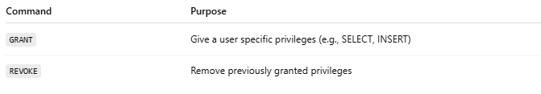
Command | Purpose
GRANT | Give a user specific privileges (e.g., SELECT, INSERT)
REVOKE | Remove previously granted privileges

📘 Examples:

🔹 GRANT
# Source: AI Source: Provided by: [Data Path: Persons Table -> ID Column: 1, Name_En Column: Motasem Essam] -> From: [ChatGPT] on [6/11/2026]
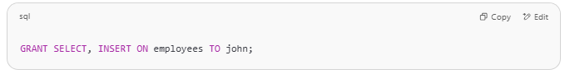
GRANT SELECT, INSERT ON employees TO john;

➡ Grants user john permission to view and add data to the employees table.

🔹 REVOKE
# Source: AI Source: Provided by: [Data Path: Persons Table -> ID Column: 1, Name_En Column: Motasem Essam] -> From: [ChatGPT] on [6/11/2026]
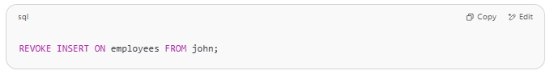
REVOKE INSERT ON employees FROM john;

➡ Removes the ability for john to insert data into the employees table.

🔐 What Can You Control with DCL?
# Source: AI Source: Provided by: [Data Path: Persons Table -> ID Column: 1, Name_En Column: Motasem Essam] -> From: [ChatGPT] on [6/11/2026]
- Table access (SELECT, INSERT, UPDATE, DELETE)
- Database access (connect rights)
- Object-specific permissions (views, procedures, etc.)
- Admin-level permissions (depending on DBMS)

🚫 Important Notes:
# Source: AI Source: Provided by: [Data Path: Persons Table -> ID Column: 1, Name_En Column: Motasem Essam] -> From: [ChatGPT] on [6/11/2026]
- DCL statements don’t affect data or structure — only permissions.
- Typically used by DBAs (Database Administrators).
- Some systems (like MySQL or Oracle) have extended privilege management systems beyond GRANT/REVOKE.

✅ In your folder system:
# Source: AI Source: Provided by: [Data Path: Persons Table -> ID Column: 1, Name_En Column: Motasem Essam] -> From: [ChatGPT] on [6/11/2026]
📁 6 - SQL Commands - DCL is for:
- GRANT
- REVOKE
- (In some systems: DENY)
Let me know if you want to include user creation or role-based access control examples!

